**Name:**  Ahmed Alaa Eldin Nageb

**Section:** 5

**B.N:** 107

**Topic:** Artificial intelligence

**Application brief**: Over the last ten years, argumentation has come to be increasingly central as a core study within Artificial Intelligence (AI). The articles forming this volume reflect a variety of important trends, developments, and applications covering a range of current topics relating to the theory and applications of argumentations

**Screenshots**:

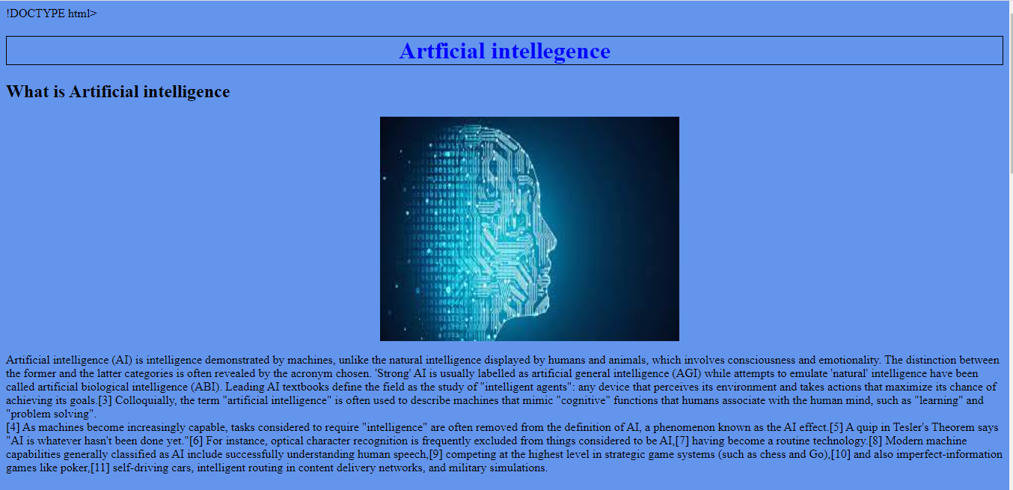

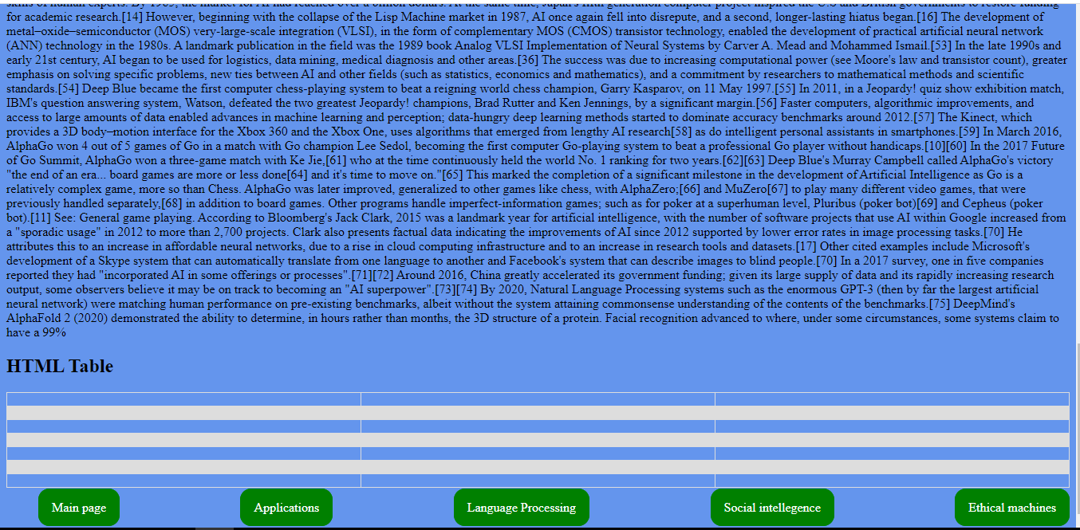

**Source code:**

